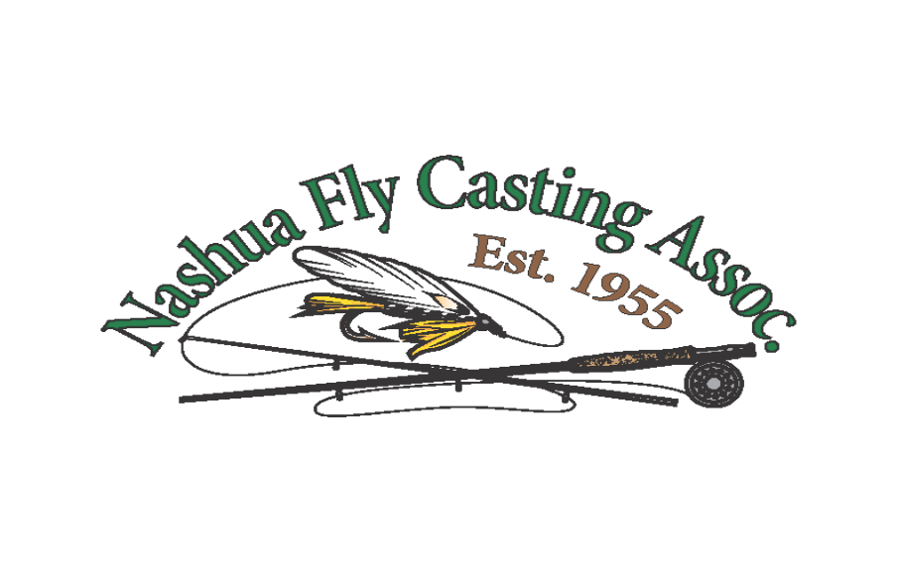
Nashua Fly Casters

October 12, 2017 Meeting Minutes
Meeting started at 6:45 PM. Those members in attendance were Bob Cox, Steve Descoteaux, Brenda Philippon, Ray Philippon, Alan Sherburne, Mariel Sherburne, Kare Karlsen, Russ Bartlett, Seth Harris, Charles Jaglinski, Mary Weiss, Burr Tupper, Don Westcott, David Braica, Bob Broadhurst, Mead Jordan, and speaker, Rick Little of Shadcreek Flies.

The minutes were voted on and accepted. Kare Karlsen reported that the treasury is again in FAIR shape with a cash balance of $1,622. He stated that will leave us in good shape to purchase $1,000 worth of fall fish.

Ray mentioned that Harry Mink had surgery on Friday, Oct.6th and that Molly had called and reported that he is healing nicely.

NEXT MEETING
October 12, 2017
Nashua Country Club
Program: 50/50 Raffle
MEETING at 6:00pm

PLEASE BRING FISHING ITEMS TO RAFFLE OFF. You can keep ½ the money offered and the club gets the other half….OR, you can give all money to the club.

OLD BUSINESS:
Ray reported that he had surveyed the pond and mentioned that the post holding the sign with the unreadable pond rules was in very good shape. He suggested we use this post for the new large NFC sign that will be installed on the curve of the driveway as you come into the pond. A motion was passed to install the post. Kare Karlsen and Steve Descoteaux offered their help to install it. Ray has purchased and will install the new hardware that will hold the buoys and ropes.

.NEW BUSINESS
Ray told that group that he bought a LIGHTLY used trail camera to be used for the video detection of the “poachers” that frequent the pond. Model is Bushnell and the cost was $90.00. It can detect motion up to 100ft and will take view shots up to 150ft. It was a bargain because a new one retails for $150.00. He explained that if for some chance reason it did not work for our use at the pond, then he would keep it for his personal use and it will cost the club nothing. There was another very used camera available for $29.00, but when he went back to the store it had been sold.

Mark Thornton visited the pond to take the temperature of the water to determine when we can do the fall stocking. Temp was 65 degrees. He then phoned Jesse who was totally surprised it was still too warm. He suggested that we wait until the temp is gets down to 60 degrees or less. Jesse is concerned that since his ponds are 47 degrees it would be too much of a shock to the fish and some could very well die. Jesse also suggested that we consider stocking more of his smaller fish to help him and he will give us a few more than he normally would. This would also help him have more, larger fish for the Spring stocking. Mark will check the temps again around Oct.20/21.
Ray asked members how much we wanted to spend for fall stocking and all agreed to spend $1000 since the fall trout hold over well during the winter months.
.
Once again Kare Karlsen mentioned that our website costs are $21for hosting and $50 to maintain per month, which is hurting our bottom line. He mentioned that we can save money by posting minutes and updating the website every 3 months; and that the minutes can be EMAILED to members monthly so that we are all can still be kept current on a regular basis. Ray and members agreed to this suggestion but Ray mentioned that we will need someone to do the up-dating.

Ray had Burr Tupper speak to members regarding tying tube flies. You can tie the same patterns as you do now; the flies promote better hooking capabilities and less loss of fish; and, there is much less damage to the flies because they move away for the fish’s mouth once hooked. He will provide all the tying materials and bring vises and will update Ray on the dates he will do the instructions.
MARY WEISS OFFERED TO BRING DESSERT….THANK YOU, MARY
Respectfully submitted,
Harry Mink, Secretary and Brenda Philippon
“A wild trout in its native habitat is a compact example of the Earth working well…”
Christopher camuto

